Weekly commodity update
Accelerating growth in Asia saves the week for commodities.
By Ole S. Hansen
A relatively quiet week in the market place with riskier assets getting a boost from stronger than expected economic data out of China, Australia and Japan.
As appetite for risk returned the dollar retraced some of its recent gains. Government debt sale by Spain and Italy was well received leading to a narrowing of spreads over German government bonds. This was still not enough to drive the Euro back above the important 1.2150 level versus the dollar indicating continued nervousness about the sovereign debt situation and the worry that it may spread east.
The Reuters Jefferies CRB Index had a good week rising 2.8 percent but stays stuck in a range between 247 and 259. Soft commodities such as sugar and coffee both rose more than seven percent while broad based gains seen across the other sectors. Natural gas reached its initial upside target at 5.00 before running into profit taking losing one percent on the week.
WTI Crude oil rose 3.5 percent on the week with buyers returning as the dollar lost ground. The move above 75.80 proved short lived and range trading remains the favored strategy until further clarification about demand and the direction of the dollar becomes clearer. Retail sales in the U.S. came out weaker than expected putting the energy sector under some selling pressure into the weekend as worries about a double dip recession still lingers.
Technically WTI Crude for July delivery has still not managed to break any significant upside levels. Keep an eye out for a close above 75.80 which would signals renewed strength towards 78.50. Support is located at 72.75 followed by 69.50.
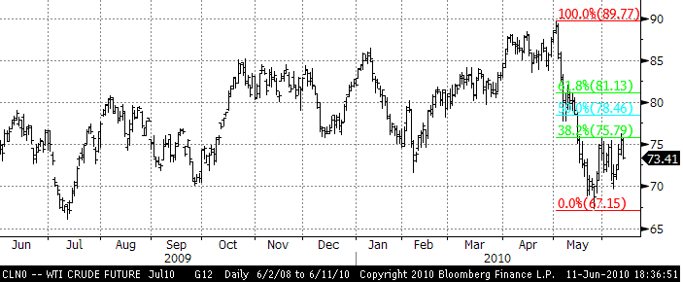
Gold rallied to a new record at 1,252 but resistance held and profit taking followed. Total holdings in gold ETFs continues to rise at an amazing rate reaching 65.4 million ounces or more than 2,000 tons.
Warren Buffett this week joined George Soros in describing gold as being in a bubble situation. Soros who himself is long of gold, contrary to Buffett, back in January called gold the “ultimate asset bubble”. He also at the same time stated that it was great riding a bubble as even though they could be rather messy when they pop a lot of money could be made riding them.
If indeed the current situation can be described as a bubble it is also worth looking at the characteristics of a typical bull market bubble. The top of a bubble is usually marked by a final surge that explodes higher. Considering gold is “only” up 12 percent year to date such a move remains to be seen. In the meantime weak long positions may head for the exit on a move below 1,195 while the long term investor probably will remain invested above the long term trend line support at 1,145.
We are cautious of further progress at this time given the unprecedented amount of funds invested in gold, especially through ETFs as mentioned. Going against the trend at this juncture is probably premature but investors should have an exit level defined should a sell off occur. Resistance at 1,250 is firm with a move above signaling an extension towards trend line resistance at 1,375. Support at 1,195 followed by 1,165 and 1,145.
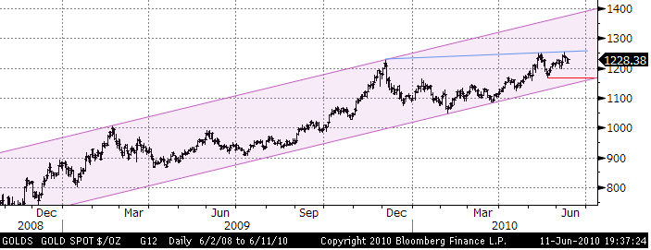
The gold to silver ratio has decreased recently from 70 (Gold price / silver price) down to 67 signaling silver outperformance. This could continue, at least short term, as the silver chart looks less toppish with further room to go before major resistance is met.
The price of Corn finally found some support this week as the monthly supply and demand data from the USDA showed an unexpected drop of this year’s stockpiles. The single biggest contributor to this drop could be found in the rising ethanol production which is used as a fuel substitute. Currently US congress has set a limit of 10% ethanol mixed into petrol but major ethanol producers have asked regulators to increase this limit to 12%.
Falling prices due to near perfect growing conditions in the Midwest have been the main focus until now. The corn future for December delivery at one stage showed a loss for the year of 20% before finding support at 353, the September 2009 low.
This announcement lends further support to the long corn short wheat ratio trade. During the past month corn has outperformed wheat by 10 percent and with the ethanol story finally having an impact this outperformance look set to continue. One word of caution is news that Australia, the fourth largest wheat exporter, is facing a potential threat from the worst locust plaque in more than two decades.
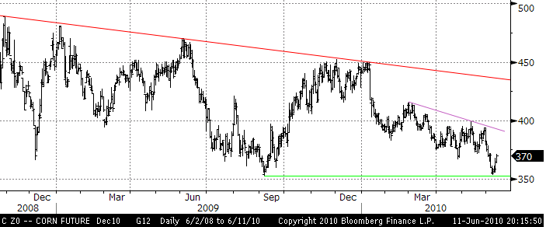
Resistance on December corn can be found at 372 followed by 392 and 400 while support is at 353.
Other commodities in brief:
Robusta coffee which is used in instant coffee and blends rallied strongly Thursday and Friday on signs of reduced supplies from Vietnam. Exports from the world’s biggest grower of that variety fell 20% from a year earlier leaving European stockpiles lower. Arabica, the finer quality coffee, primarily from Brazil and traded in New York rose 7 percent on the back of the 11 percent gain reported on Robusta.
Having traded as low as 1,282 dollar per metric tons back in March the price for September robusta reached 1,538 on Friday as traders and hedgers scrambled for cover. Once the market stabilizes new sellers will probably emerge given the size of the recent rally and long term fundamentals which points to the market being well supplied.
Copper had its first decent weekly gains since the sell off began back in April. The weaker dollar looks like the main driver behind the move although Chinese export figures which jumped to a five year high also helped sentiment. Although we saw growth accelerating in the Asia this week, we are concerned that China will hit the brakes harder than the market currently forecast. Should this materialize we could see base metals suffer as we head towards Q3 and Q4. We see the risk of copper dropping quite substantially towards the end of the year, retracing much of the gains made since Q1 of 2009.

