Global markets bounce ahead of US earnings season.
Stock markets had their best weekly gains for the year last week as risk willingness returned ahead of the US Q2 earnings season which kicks off soon.
Commodity markets joined the positive trend with the Reuters Jefferies Commodity index rising 2.3 percent as of last Friday. The grain sector continues to find the strongest support with the price of wheat having rallied by 17 percent this past month on very hot weather in crop growing regions in Europe and Russia combined with excessive wet weather in the US Midwest.
One story in the gold market has caused a great deal of confusion. Last week the Bank for International Settlements, in their latest annual report, announced that they were holding 346 tons of gold in exchange for foreign currency. The timing of the swaps led many to believe that Central Banks from weaker European nations had used the facility to boost their cash reserves at a time where they were struggling to raise finance through regular channels.
Some worried that this gold somehow would find its way to the market and put pressure on prices. Gold initially took the news badly dropping to a six week low before physical buyers re-entered the market below 1,200. Important support at 1,195 was breached but buyers held it from dropping below 1,185 resulting in the emergence of a thirty dollar trading range with 1,200 in the middle.
Before the news broke speculators had already been busy reducing positions on Comex in New York with the speculative long position as of last Tuesday dropping by 14.5 percent or 4.6 million ounces. Whether the BIS related sell off has reduced this position further will only be known this coming Friday. The market is somewhat neutral at these levels as much of the buying related to sovereign debt fears have now been reduced.

Gold held in ETFs stands at 66.6 million ounces, the equivalent of 2,080 tons.
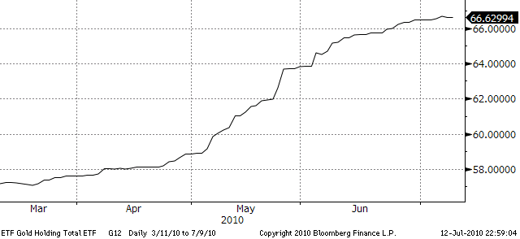

It is worth pointing out that holding in gold ETFs continues to be firm with no reductions seen during the past week. The fear about a double dip recession and the effect that would have on other asset classes leaves it supported.
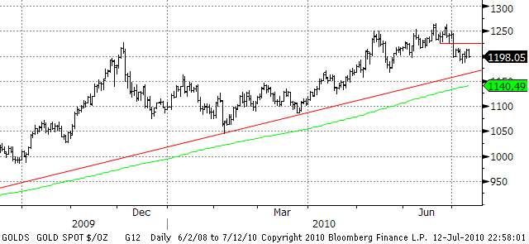
With market activity being low due to summer holiday in the northern hemisphere the gold market is likely to take its cue from outside events such as the dollar and the US earnings season. Near term support is last week’s low at 1,185 followed by important levels at 1,165 and 1,140 with the latter being 200 day moving average. Resistance can be found at 1,225 followed by the recent high at 1,265.
Energy markets continue to gyrate amid reduced activity during the summer months. Last week’s gain was helped by a combination of record temperatures throughout the Northeastern US, a weaker dollar and firmer global equity markets. The DOE inventory report showed a huge draw of 5 million barrels as import disruptions are still evident in the Gulf of Mexico. A wide trading range is in the process of being established while we wait for additional fundamental news from the sector.
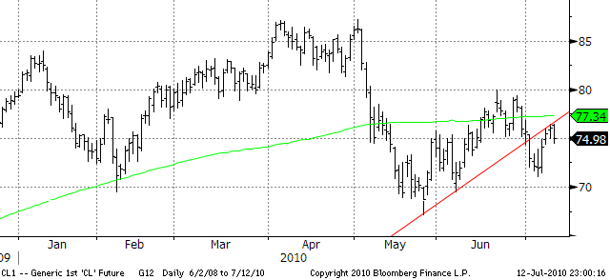
Traders are still not seeing demand picking up enough to warrant a rebuild of long positions. The speculative long position of Nymex crude actually fell by 30 percent or 10.9 million barrels last week. On this basis we expect range trading to prevail for now with support on the near month crude contract located at 71 followed by the May low at 68.59. Major resistance above is the 200 day moving average at 77.30 followed by 79.40.
Later this week China will release a host of economic data including inflation and industrial production, this combined with the already mentioned Q2 earnings from US companies will be the main focus.

