The US Dollar sets the tone.
Alan Plaugmann, Deputy Head of CFDs and Listed Products

The strong global equity rally has provided the main lift in the commodities rally lately. However, there are signs that the current rally in equities is running out of steam, which leave commodities under some pressure. The US FED is prepared to ease further keeping rates at record low levels for some time, yet. In Europe the default risk of weaker nations continues at elevated levels, which remains to be the dark cloud over recovery pundits. That being said it still would appear that investors are overlooking many of the bad signs in the economy for now.

Although the CRB index is relatively flat, or only slightly positive, on the week as the energy sector continues to struggle, with what appears to be declining momentum. Overall, the general commodities complex is still failing to move higher, as is has revisited resistance levels seen several times this year.

Crude inventories continue to stay healthy and considerably above cyclical averages for this time of the year, with the same story applying to that of gasoline stocks, too. There really is no sign of this trend being bucked. The current supply situation does indicate that fundamentals are currently not strong enough to support a strong bullish move in Crude. Actually, one of the main support factors as been the US dollar strength, which is currently under pressure, too, and could prove detrimental if the weakness continues.

Crude Oil remains inside the longer term bullish trend, however has failed to move above the 50 day moving average, which has been a good indicator for the bullish trend. The longer term trend will come under fire at a move downwards towards the 71.80 level. Lower highs in the price action can typically signal slowing momentum and price weakness. A firm break of 71.80 could leave Crude in danger of further losses, targeting the low side of the 60’s, which will constitute a break of the longer term trend.

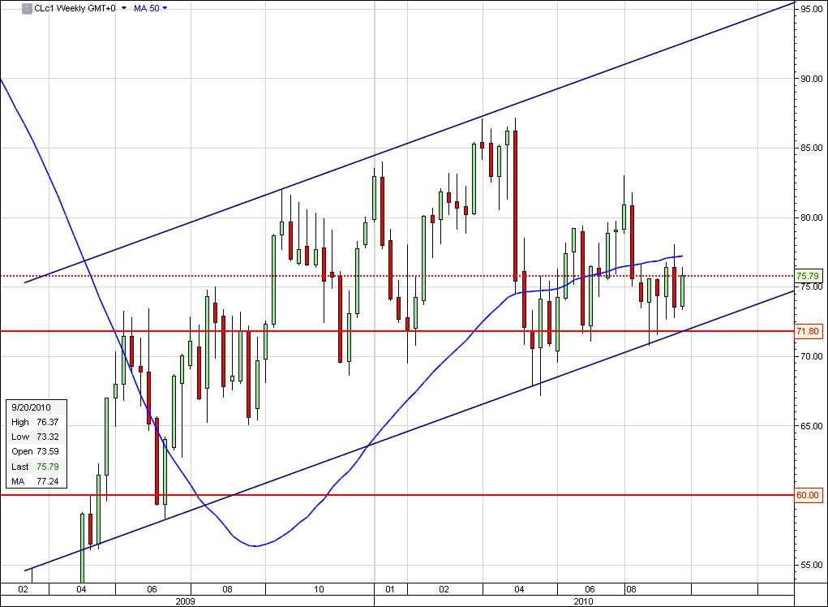

We are entering a season with a traditionally strong transportation demand both for oil and dry bulk. Rough seas and weather delays usually provides additional support to freight rates. On the flip-side the vessel supply has never been larger.
With the global vessel supply being so high, it is likely to keep VLCC (Very Large Crude Carriers) rates subdued in the coming months, unless of course the contango of the oil curve becomes steep enough to warrant placing the vessels on floating storage or the ship-owners decide to remove vessels for maintenance.
In dry bulk, the demand for capesize vessels is dampened by the recent energy saving campaign and the real estate curbing measures in China. The main drivers for panamax size vessels is the US grain export, that looks to outpace last year’s levels, the Indian iron ore season and the early winter coal fixtures.
The US grain sales outpaced levels compared to last year. However, corn continues to outperform wheat trading and stockpiles could continue to drop to low levels not seen since 2007-08, as livestock farming also switches to corn in lieu of lost wheat production.
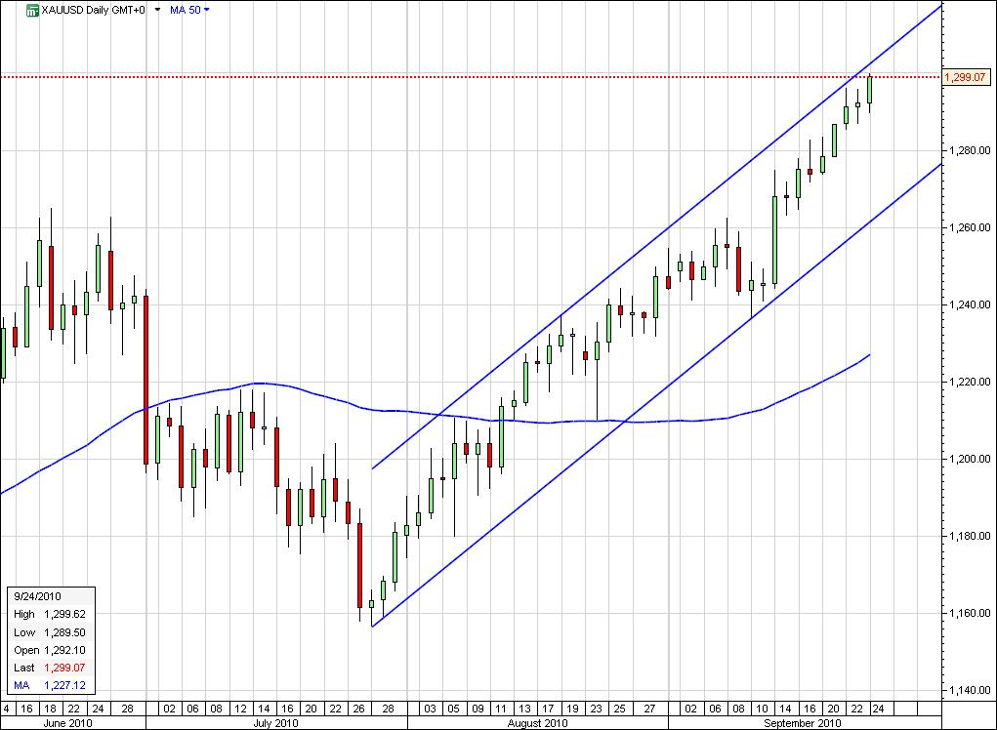

The US dollar is very much in focus across most of the denominated assets. The recent losses has had an effect on commodities in general, none the more so than Gold. All time highs have been reached, falling just short of $1.300 on the spot markets. The main contributors to the bull market appear to be central banks and producer hedge book buybacks, but anecdotal evidence around the market shows that most eyes are focused on the US dollar.
The renewed strength and momentum has driven Gold to what appears to be the top of the longer term upward trend channel, however as we are also in “uncharted” territory, with respect to the price action, we do expect some volatile trading sessions in the near future, as the market gears itself to new levels.

Finally growers of oranges in Florida will be keeping a close eye on tropical storm Igor which is approaching and if turning into a hurricane could damage citrus groves in the Sunshine State. Futures prices have risen the most in eight months on the back of this risk.

