Commodity weekly: Markets on hold until US Fed meeting.

By Ole S. Hansen

Global market activity has been grinding to a halt as we await the outcome of the U.S. midterm election on
Tuesday and more importantly the Federal Reserve meeting on Wednesday.
How much quantitative easing? This is the question currently keeping the market stuck in relative tight ranges as for the first time in many months the outcome has been very difficult to establish. Over the past week we have seen expectations being lowered from aggressive to a measured approach from the Federal Reserve. This has stopped the dollar from weakening further and as a result riskier positions have been scaled back.
The earnings reported by US companies in the third quarter has been better than expected but stocks have so far failed to react accordingly as some improved data had already been priced in. Meanwhile in Europe bond yield spreads between weaker and stronger nations have begun to widen again as some countries are finding it increasingly difficult to implement the public spending cuts needed to meet the 2014 deficit targets. So far the Euro has been relatively unhurt by this renewed focus on Europe but a situation worth keeping an eye on considering the importance that currency levels has on other asset classes like commodities.
October turned out to be the best month this year for several commodities with the Reuters Jefferies CRB index returning five percent on the month bringing the year to date return up to six percent. Main performers as seen below belongs to the agricultural sector as highlighted in previous updates. The index heavy energy sector continues to trade sideways with natural gas once again one of the worst performers. Also worth mention is the dramatic outperformance of silver over gold which year to date now stands at twenty percent.

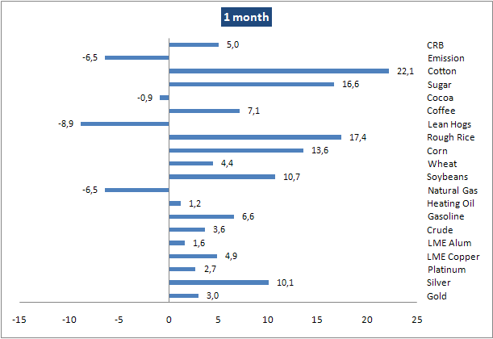

Gold has been trading defensively now for the past week waiting, like most other markets, for the FOMC meeting next Wednesday. Room for maneuver has decreased as it currently finds itself stuck between resistance above 1,350 and trend line support at 1,324.
Should the QE2 injection of liquidity disappoint a deeper correction could be the result while on the positive side some long positions
have now been liquidated leaving renewed room to the upside. Fibonacci levels at 1,299 and 1,272 should provide support on a sell off while resistance above the recent high at 1,387 will be the physiological level at 1,400.
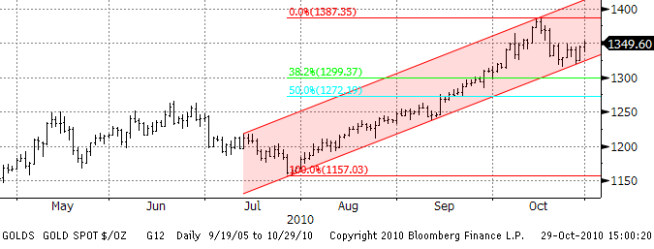

This week an unofficial comment from China this week said that they should build gold reserves equaling the US. China’s current gold reserve is around 1,000 tons compared to some 8,000 tons in the US. This highlights the current mood among central banks towards increasing their holdings after having been net sellers over the past twenty years. If not now then at least over the long run this should be supportive for gold.
WTI crude oil finds itself entrenched in the 80 to 85 range for the fourth week but still on course to register a second month with gains. Just like other commodity markets the outcome and subsequent impact on the dollar will be the main focus over the next week. There are some evidence that supply fundamentals in the US appears to be tightening on the back an expected drop in import over the coming weeks. This should keep prices supported but based on the performance over the past few months the dollar needs to resume its weakening trend in order for 85 dollars and beyond to be tested.
The cost of shipping crude on large crude carriers rose by 40 percent in just three days this week as demand from the Far East moved up a gear thereby wrong footing the market. Falling prices on the benchmark route from Saudi Arabia to Japan had become the norm amid a backdrop of available tonnage looking for business. Whether this signals a change in direction remains to be seen as demand elsewhere looks stable.
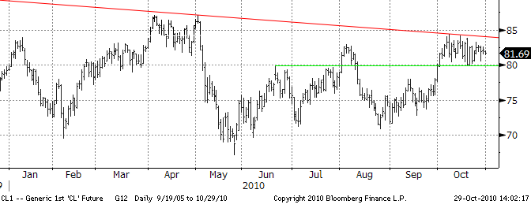We saw a reduction in the speculative long position last week and that looks set to have continued this week. A combination of disappointed longs getting out due to lack of follow through buying combined with risk being generally reduced ahead of FOMC has been the main themes this week.
Copper ran into some profit taking this week but is still on course for the fourth monthly gain. Currently copper traded on LME is up 13 percent year to date having rallied 42 percent from the June lows. Bullish noises about supply constraints in 2011 combined with ongoing talk of the possible launch of copper exchange traded funds has been given the metal some positive traction recently. The record highs from 2006 and 2008 just below 9000 dollar have been getting ever closer. However looking at the price development of copper measured in Euros it has been traded sideways for two months again highlighting the influence of the dollar.
