Impressive first quarter performance
By Ole S. Hansen, Senior Manager

Commodities saw their third consecutive quarterly gain as geopolitical risk stemming from unrest in North Africa and the Middle East drove energy prices higher.

In this process all of the three major commodity indices outperformed the MSCI World stock index, which returned 4.3% for the quarter. Strongest was the S&P GSCI, with its heavy exposure to the energy sector, returning 11.6% while the DJ UBS, with its broader approach, returned 4.4%. In the middle we find the Reuters Jefferies CRB index coming in at 8% for the quarter.

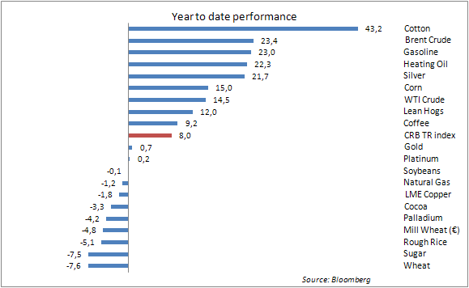

These numbers clearly highlight the mixed fortunes of different sectors with the energy sector as a whole being the best performer, while others like base metals struggled to perform. Other factors impacting prices during the first quarter were the Japanese earthquake and subsequent nuclear crisis (with the full extent still unknown) and rising inflation on the back of elevated food and energy prices.

Lingering themes
These themes will stay with us into the second quarter combined with speculation about when the world’s major central banks will end their monetary stimulus. This has put global bond markets under pressure as the cocktail of rising inflation

combined with expectations of higher central bank rates has left many investors seeking returns through the stock market instead.

Rising energy prices
Crude and refined products posted three of the four biggest gains during the quarter. After having been trading sideways for the past couple of weeks WTI rose to the highest in 30 months on a combination of investors doing some month end “window dressing”, but more importantly on concerns the conflict in Libya will prolong production cuts and put other suppliers under pressure to meet the shortfall. Muammar Qaddafi regained control of the oil port of Ras Lanuf and shelled Brega, another energy hub raising concerns that previous oil customers will find it almost impossible to deal with the current regime going forward.

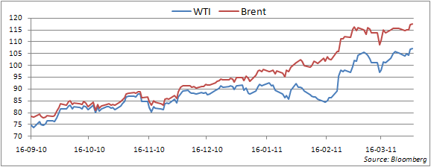

So far there is no sign of demand destruction having been detected despite the cost of Brent being up 46% and WTI up 35% on their 2010 averages. This has put pressure on Saudi Arabia, the world’s largest oil producer after Russia, to meet the shortfall as they hold most of the global spare capacity. Data so far indicates that the output in March only rose by 300,000 barrels per day, falling well short of the estimated 1.6 million bpd that is currently lacking due to the Libyan unrest.

Correction phase in grains over
The long awaited report from the U.S. Department of Agriculture which shed light on farmers planting intentions for the 2011/12 crop season was more or less in line with expectations. U.S. farmers plan to increase corn, cotton and wheat acreage in response to the dramatic price rises over the last year, while soybeans and rice lost out.

Despite seeing the second largest corn acreage since 1944 the market responded by sending corn 11% higher as inventory levels of old crops fell significantly below expectations. Stockpiles dropped to the lowest level since 2007 and the worry is that despite increased production the new crop is not expected to rebuild inventories to a sustainable level. The competition from rising gasoline prices (and thereby increased
profitability of turning corn into ethanol) will continue with 40% of U.S. production expected to be going towards fuel as ethanol production is calculated to stay profitable below a corn price of 9 dollars, some 23% away from current levels.

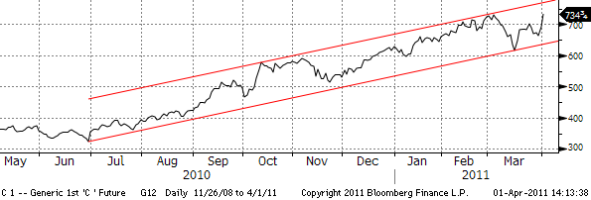

The reports were price negative for wheat but given the strong rally in corn and soybeans it finished the day higher as well. Also affected by current dry weather conditions in the U.S. plains and in China, the world’s biggest wheat producer, which has increased the risk of delayed planting and lower yields. Stock levels in Europe are already running low after the Russian export ban and increased demand from North Africa.

Key attention now turns to the weather as the grain market would have limited or no response to other weather shocks like the ones in 2010 that began the current drive towards higher prices. It would take perfect weather conditions and subsequent increased production to move us away from the precarious low stock situation. Apart from near perfect weather conditions, the only other option currently is higher prices in order to reach levels where demand destruction sets in. On this basis it looks as if the correction that was seen during the early stages of March was indeed only a correction with the risk of price moves now skewed to the upside. This does not look good for already rising food inflation and is something that will receive attention by the global media in the months ahead and will worry central banks.

Gold finish higher tenth quarter in a row
Gold finished March with the tenth quarterly rise in a row, the longest winning streak in more than three decades. It was however not by much as it spent most of March trading sideways failing to get the same kind of traction as its cheaper alternative silver. Resistance is currently firm towards 1,450 as investors have been scaling back positions ahead of the possible cessation of quantitative easing in the U.S. and a return to normalised interest rates. This reduces the competitiveness of gold and silver being non interest bearing assets.

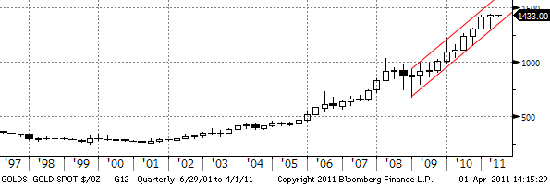

We do however not see much downside risk with sub 1,400 being well supported on the back of political risk from North Africa and the Middle East combined with Central Banks intentions of increasing their holdings. Silver which has outperformed gold by 40 percent over the last seven months has found some resistance towards 38 dollars per troy ounce with other industrial metals like copper having run into sellers recently on the back of high Chinese inventories.

NON-INDEPENDENT INVESTMENT RESEARCH
This investment research has not been prepared in accordance with legal requirements designed to promote the independence of investment research. Further it is not subject to any prohibition on dealing ahead of the dissemination of investment research. Saxo Bank, its affiliates or staff, may perform services for, solicit business from, hold long or short positions in, or otherwise be interested in the investments (including derivatives), of any issuer mentioned herein.

None of the information contained herein constitutes an offer (or solicitation of an offer) to buy or sell any currency, product or financial instrument, to make any investment, or to participate in any particular trading strategy. This material is produced for marketing and/or informational purposes only and Saxo Bank A/S and its owners, subsidiaries and affiliates whether acting directly or through branch offices (“Saxo Bank”) make no representation or warranty, and assume no liability, for the accuracy or completeness of the information provided herein. In providing this material Saxo Bank has not taken into account any particular recipient’s investment objectives, special investment goals, financial situation, and specific needs and demands and nothing herein is intended as a recommendation for any recipient to invest or divest in a particular manner and Saxo Bank assumes no liability for any recipient sustaining a loss from trading in accordance with a perceived recommendation. All investments entail a risk and may result in both profits and losses. In particular investments in leveraged products, such as but not limited to foreign exchange, derivates and commodities can be very speculative and profits and losses may fluctuate both violently and rapidly. Speculative trading is not suitable for all investors and all recipients should carefully consider their financial situation and consult financial advisor(s) in order to understand the risks involved and ensure the suitability of their situation prior to making any investment, divestment or entering into any transaction. Any mentioning herein, if any, of any risk may not be, and should not be considered to be, neither a comprehensive disclosure or risks nor a comprehensive description such risks. Any expression of opinion may be personal to the author and may not reflect the opinion of Saxo Bank and all expressions of opinion are subject to change without notice (neither prior nor subsequent).

Futures contracts are traded on margin enabling you to leverage a small margin deposit for a much greater market effect. You will be required to deposit initial margin to initiate a position. You must also maintain the Maintenance Margins listed per contract in your account at all times. If the funds in an account fall below this margin, clients will be subject to a margin call to either deposit more funds to cover positions or close positions. You will usually be notified of this through our trading platform and via e-mail. If you fail to do so as required, your position may be closed or liquidated.

Saxo Bank does not support physical delivery of the underlying security on expiry of a futures contract. You should ensure that you are aware of the expiry and first notice dates (FND) of any futures contracts and that you close these at the appropriate time. If the FND is before the expiry date, positions need to be closed the day before the FND. If the expiry date is before the FND positions need to be closed no later than on the expiry date. If futures positions are not closed before the relevant date, Saxo Bank will close the position on your behalf at the first available opportunity at the prevailing market rate. You will bear any resulting costs, gains or losses. Our Futures do not provide any right to the underlying instruments.
In certain cases, our, Futures are over-the-counter (OTC) instrument. Each Future trade that you enter into on our trading service results in you entering a contract with us; these contracts can only be closed with us and are not transferable to any other person.

This means that you may be exposed to the risk of our default. In this unlikely event, we are members of the Danish Financial Services Compensation Scheme.

The following risks relevant to any investment in this product:
- There may be significant fluctuations in the market or index underlying this investment that may give rise to losses;
- Investment will involve exposure to foreign currency exchanges rates which may move unfavourably and give rise to losses;
- This investment is based on an underlying [instrument / index / market / etc.] that is potentially unpredictable and volatile.
- There may be a sudden shift in the price of an underlying from one level to another and substantial losses may result from such movements in the underlying.
- In setting prices and contract terms, we take into consideration the market or the markets for the relevant underlying instruments. Market conditions can change rapidly over a short period of time, so if you want to close out a contract we might not be able to do so on the same terms.
- In considering the potential profit associated with any investment you should be aware of the costs and charges applicable to that product that will reduce such profitability.

This communication refers to past performance. Past performance is not a reliable indicator of future performance. Indications of past performance displayed on this communication will not necessarily be repeated in the future. No representation is being made that any investment will or is likely to achieve profits or losses similar to those achieved in the past or that significant losses will be avoided.

Statements contained on this communication that are not historical facts and which may be simulated past performance or future performance data are based on current expectations, estimates, projections, opinions and beliefs of the Saxo Bank Group. Such statements involve known and unknown risks, uncertainties and other factors, and undue reliance should not be placed thereon. Additionally, this communication may contain 'forward-looking statements'. Actual events or results or actual performance may differ materially from those reflected or contemplated in such forward-looking statements.

This material is confidential and should not be copied, distributed, published or reproduced in whole or in part or disclosed by recipients to any other person.

Any information or opinions in this material are not intended for distribution to, or use by, any person in any jurisdiction or country where such distribution or use would be unlawful. The information in this document is not directed at or intended for “US Persons” within the meaning of the United States Securities Act of 1993, as amended and the United States Securities Exchange Act of 1934, as amended.

This disclaimer is subject to Saxo Bank's Full Disclaimer available at www.saxobank.com/disclaimer.

