FED action feeds the “commodity bull”
By Ole S. Hansen, Saxo Bank
This week’s announcement from the U.S. Federal Reserve that QE2 will cease in June but will be followed by an extended period of low interest rates was what the market had been hoping for. As a consequence the dollar continues its slide towards the bottom while supporting the continued bull markets in equities and commodities.
The Reuters Jefferies CRB index is flat in the week but showing a positive return of 10% year to date, which is rather impressive after just four months. During the same period, however, the dollar has lost nearly 8% versus a basket of currencies which leaves non dollar based investor’s nearly flat year to date.
Easy monetary policy has speculators piling into silver and gold
Currently there seem to be no clouds on the horizon when it comes to investing in gold and silver. Prolonged low U.S. interest rates, which carry the risk of triggering higher future inflation, and a weaker dollar, combined with the sheer momentum of investor money continuing to pile into the metals, have driven both to new highs during April.

During this week silver broke some amazing records. First of all it reached the Hunt brothers’ high from 1980 just below 50 dollars. On Monday the trading frenzy saw the iShares Silver Trust ETF trade more volume than the SPDR S&P 500 ETF, normally one of the most actively traded securities in the world. Futures volumes also exploded as the CME Group reported a turnover of 319,205 contracts, a 58.6% jump from its previous record in November.
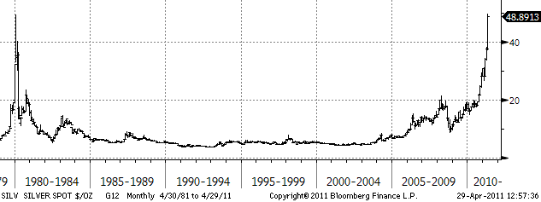

Some of the volume was undoubtedly the result of short covering with short sellers capitulating amid the ongoing surge which saw silver rise by 25% in just eight trading sessions. Daily trading ranges during the past week have been between four and nine percent which makes it increasingly difficult to trade with the $45 to $50 range not expected to hold for long. The fundamentals and momentum continues to support precious metals but heavy bouts of profit taking are always a danger. Near-term silver support can be found at 45 followed by 42.

The move in gold has been much slower with silver continuing to outperform. Against the other major currencies the performance year to date has been pretty flat with EURO gold showing a negative return of 2.5%. Central Banks continue to favour gold with former sellers having turned into buyers and this combined with negative real rates continues to support gold. Support can be found at 1,490 before major at 1,455.

Gasoline the driver
U.S. gasoline prices continue to be the upside leader outperforming crude oil. This week the price jumped to a 33 month high with 10 straight weeks of inventory declines bringing to their lowest levels since August 2009. As a consequence the U.S. retail gasoline price at the pump reached $3.88 per gallon, only some 5% below the 2008 peak. This inventory decline and price rise has become a hot potato, both politically and financially as the driving season is only a month away.

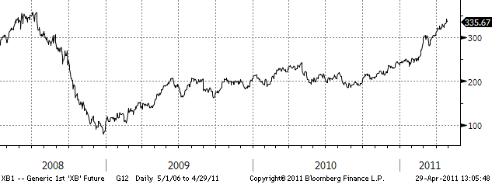

Crude oil still supported by events
The factors that have driven the price of Brent crude up by 31% this year have not gone away. Unrest in North Africa and The Middle East has not diminished with Libyan oil still not expected to reach the market for months. Add to this a weak dollar and stubbornly strong Chinese demand, which in March rose by 10.6% year on year to 9.1 million barrels per day.

What could pull prices lower are fears that the recovery may be slowing down as seen through weaker than expected U.S. growth during the first quarter. ARAMCO in Saudi Arabia was out this week expressing their concerns about high prices and the potential impact on global growth. Meanwhile the speculative position held by hedge funds and large investors is back up to 300 million barrels representing a nominal value of $34 billion.

Near term Brent crude is confined to a trading range between 119 and 127 per barrel.

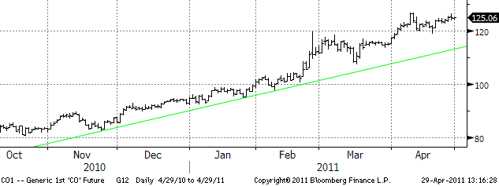

Weather is playing havoc with grain planting and prospects
As mentioned in previous updates the main market driver for the grain markets over the next couple of months will be weather developments across growing regions. Last week we saw strong performance from wheat as dry weather conditions in southern U.S. states, Canada, France, Germany and China drove prices 10% higher before improved forecasts sent the price crashing back down by the same amount.

Corn has been affected in a similar fashion but this time by too much rain across the U.S. Midwest which has been hampering spring planting and putting additional pressure on always depleted stock levels. But again, just like wheat improved weather forecast saw prices fall heavily on Thursday. This highlights the weather volatility ahead. It is no wonder that the grain traders on the old futures pit in Chicago allegedly used to sleep with one foot outside the window to be the first to know of any change in weather patterns.

Cocoa recovering from lows
Cocoa priced saw sharp gains this week on concerns that tensions in the Ivory Coast could reignite. The recovery has now seen the market retrace more than 50% of the March sell off.

Sugar continues to slide
The February peak at 29.75 is now only a distant memory as sellers have been in the driving seat during April. Thailand, the world’s second largest exporter after Brazil, expects a bumper crop of 9 million tonnes, up 30% from last year. Potential exports from India, combined with good weather prospects in Brazil, have helped sellers while the speculative long position is still relatively high at 122,000 lots, albeit down from 200,000 lots in February.

Cotton demand waning
Cotton, the star performer over the past year, has seen a sharp reversal during April as high prices have begun to strangle demand at a time where global supplies are climbing. China, the largest cotton importer has increasingly been cancelling orders which in turn have helped remove some of the deficit in the market. One thing to look out for is U.S. planting, which is behind schedule due to the hot dry weather conditions which have also impacted wheat.

Coffee above $3
The price of high quality Arabica coffee has breached $3 per pound for the first time in more than 34 years with investors and roasters competing for limited supplies. Inventories are at a 50 year low with espresso connoisseurs craving for the high quality bean continuing at a time where supplies from Columbia and other top producers have been disappointed.

Copper on growth watch
Copper has been trading sideways with a slight downward bias over the last three months. Worries about continued tightening of Chinese monetary policy and a general reduction in global growth expectations on the back of high energy prices have been the main focus. Stockpiles in China, the world’s biggest consumer, have been rising aided by Chinese investors who to a greater extend have been using copper as collateral for loans. Overall the composite index of base metals is showing a small gain on the year with negative performances in lead, copper and zinc more than offset by strong gains in tin, aluminum and nickel.

Natural gas working on the floor
More than six months of sideway trading has begun to incite the belief that a floor below $4 has been established. Open interest on the futures is near a record high, while the large speculative short position held by hedge funds and large investors is stuck at close to 200,000 lots. The Japanese nuclear disaster has increased the use of natural gas with U.S. nuclear output seeing a reduction while 23 U.S. reactors, with similar design to the Fukushima nuclear plant come under review. During this past week nuclear power output dropped to the lowest level in 10 years after tornadoes slammed into the southern states knocking out power plants. For now the spot month stays range bound between $4 and $4.8.

NON-INDEPENDENT INVESTMENT RESEARCH
This investment research has not been prepared in accordance with legal requirements designed to promote the independence of investment research. Further it is not subject to any prohibition on dealing ahead of the dissemination of investment research. Saxo Bank, its affiliates or staff, may perform services for, solicit business from, hold long or short positions in, or otherwise be interested in the investments (including derivatives), of any issuer mentioned herein.

None of the information contained herein constitutes an offer (or solicitation of an offer) to buy or sell any currency, product or financial instrument, to make any investment, or to participate in any particular trading strategy. This material is produced for marketing and/or informational purposes only and Saxo Bank A/S and its owners, subsidiaries and affiliates whether acting directly or through branch offices (“Saxo Bank”) make no representation or warranty, and assume no liability, for the accuracy or completeness of the information provided herein. In providing this material Saxo Bank has not taken into account any particular recipient’s investment objectives, special investment goals, financial situation, and specific needs and demands and nothing herein is intended as a recommendation for any recipient to invest or divest in a particular manner and Saxo Bank assumes no liability for any recipient sustaining a loss from trading in accordance with a perceived recommendation. All investments entail a risk and may result in both profits and losses. In particular investments in leveraged products, such as but not limited to foreign exchange, derivates and commodities can be very speculative and profits and losses may fluctuate both violently and rapidly. Speculative trading is not suitable for all investors and all recipients should carefully consider their financial situation and consult financial advisor(s) in order to understand the risks involved and ensure the suitability of their situation prior to making any investment, divestment or entering into any transaction. Any mentioning herein, if any, of any risk may not be, and should not be considered to be, neither a comprehensive disclosure or risks nor a comprehensive description such risks. Any expression of opinion may be personal to the author and may not reflect the opinion of Saxo Bank and all expressions of opinion are subject to change without notice (neither prior nor subsequent).

Futures contracts are traded on margin enabling you to leverage a small margin deposit for a much greater market effect. You will be required to deposit initial margin to initiate a position. You must also maintain the Maintenance Margins listed per contract in your account at all times. If the funds in an account fall below this margin, clients will be subject to a margin call to either deposit more funds to cover positions or close positions. You will usually be notified of this through our trading platform and via e-mail. If you fail to do so as required, your position may be closed or liquidated.

Saxo Bank does not support physical delivery of the underlying security on expiry of a futures contract. You should ensure that you are aware of the expiry and first notice dates (FND) of any futures contracts and that you close these at the appropriate time. If the FND is before the expiry date, positions need to be closed the day before the FND. If the expiry date is before the FND positions need to be closed no later than on the expiry date. If futures positions are not closed before the relevant date, Saxo Bank will close the position on your behalf at the first available opportunity at the prevailing market rate. You will bear any resulting costs, gains or losses. Our Futures do not provide any right to the underlying instruments.
In certain cases, our, Futures are over-the-counter (OTC) instrument. Each Future trade that you enter into on our trading service results in you entering a contract with us; these contracts can only be closed with us and are not transferable to any other person.

This means that you may be exposed to the risk of our default. In this unlikely event, we are members of the Danish Financial Services Compensation Scheme.

The following risks relevant to any investment in this product:
- There may be significant fluctuations in the market or index underlying this investment that may give rise to losses;
- Investment will involve exposure to foreign currency exchanges rates which may move unfavorably and give rise to losses;
- This investment is based on an underlying [instrument / index / market / etc.] that is potentially unpredictable and volatile.
- There may be a sudden shift in the price of an underlying from one level to another and substantial losses may result from such movements in the underlying.
- In setting prices and contract terms, we take into consideration the market or the markets for the relevant underlying instruments. Market conditions can change rapidly over a short period of time, so if you want to close out a contract we might not be able to do so on the same terms.
- In considering the potential profit associated with any investment you should be aware of the costs and charges applicable to that product that will reduce such profitability.

This communication refers to past performance. Past performance is not a reliable indicator of future performance. Indications of past performance displayed on this communication will not necessarily be repeated in the future. No representation is being made that any investment will or is likely to achieve profits or losses similar to those achieved in the past, or that significant losses will be avoided.

Statements contained on this communication that are not historical facts and which may be simulated past performance or future performance data are based on current expectations, estimates, projections, opinions and beliefs of the Saxo Bank Group. Such statements involve known and unknown risks, uncertainties and other factors, and undue reliance should not be placed thereon. Additionally, this communication may contain 'forward-looking statements'. Actual events or results or actual performance may differ materially from those reflected or contemplated in such forward-looking statements.

This material is confidential and should not be copied, distributed, published or reproduced in whole or in part or disclosed by recipients to any other person.

Any information or opinions in this material are not intended for distribution to, or use by, any person in any jurisdiction or country where such distribution or use would be unlawful. The information in this document is not directed at or intended for “US Persons” within the meaning of the United States Securities Act of 1993, as amended and the United States Securities Exchange Act of 1934, as amended.

This disclaimer is subject to Saxo Bank's Full Disclaimer available at www.saxobank.com/disclaimer.

